PySpark Assignment[26-12-2023]

By Karthikeyan K R

Installing Jupyter-Lab

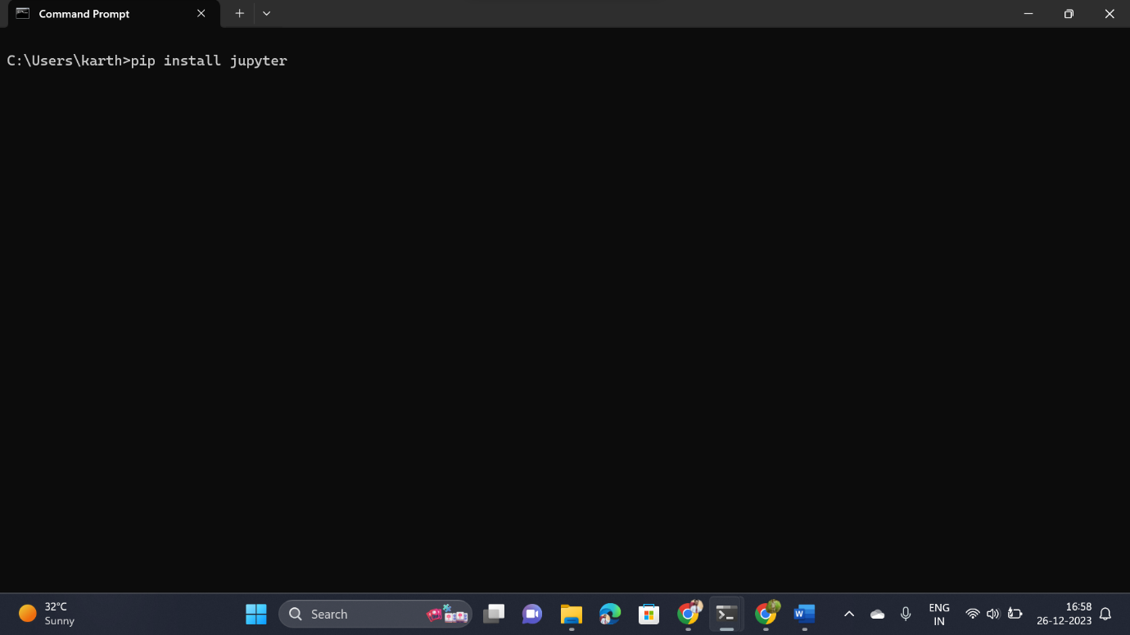

Installing FindSpark

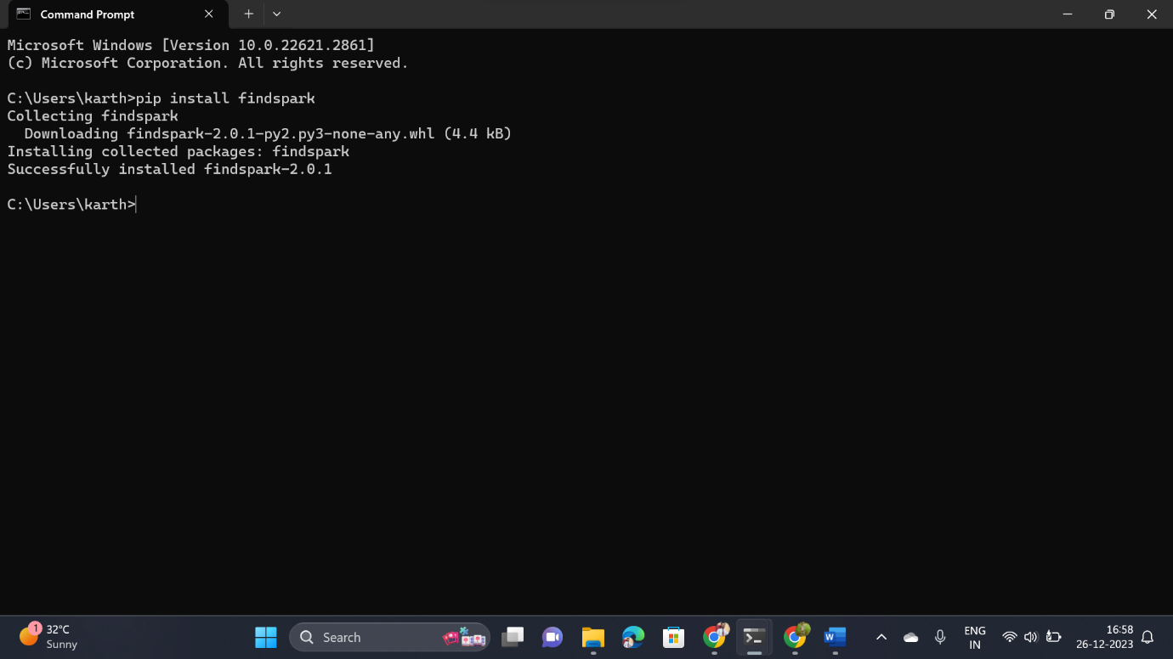

Launching Jupyter-Lab from CMD:

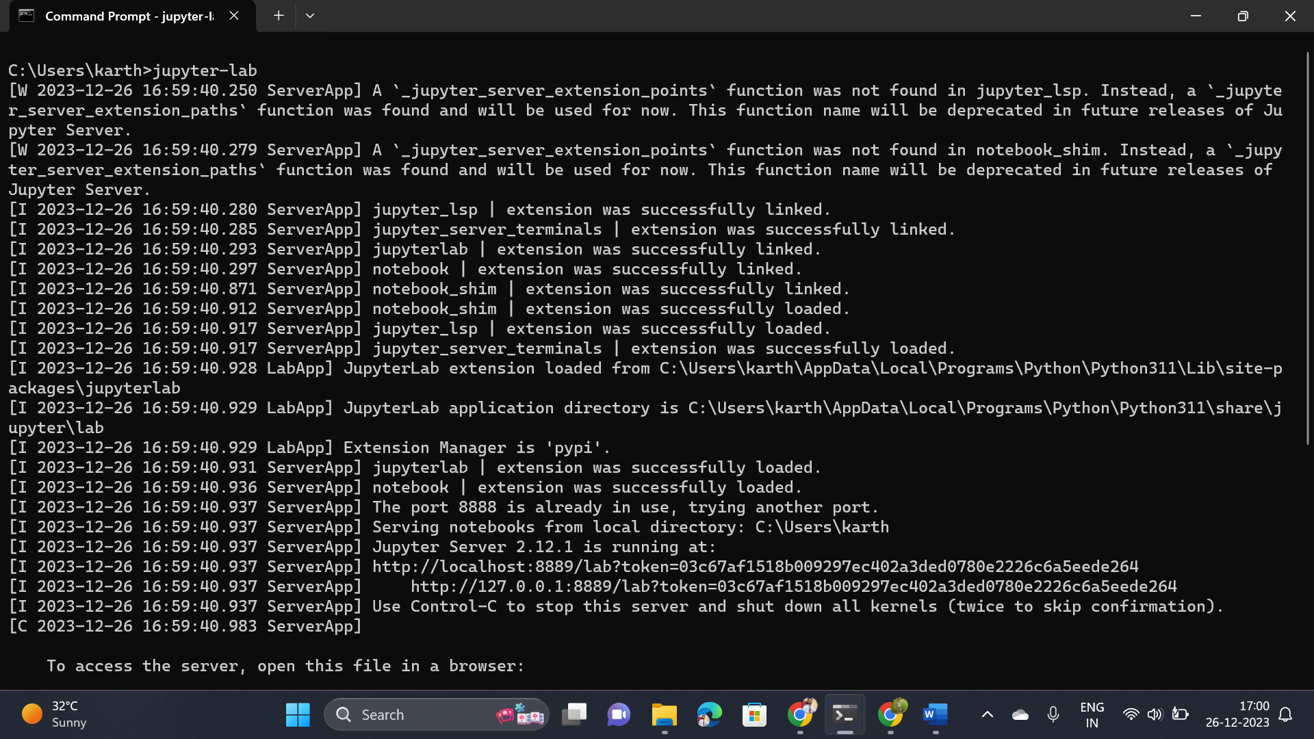

Jupyter-Lab Interface

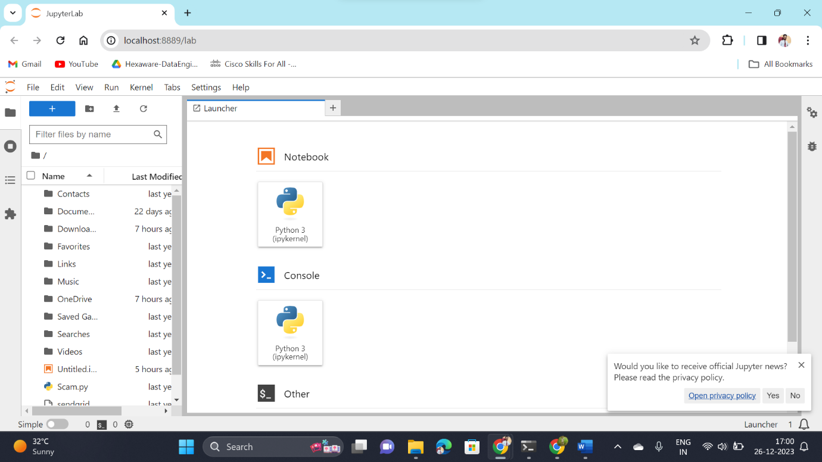

My First PySpark Program

